WordPress Deployment on EC2 Using One Bash Script

Step 1 — Launch EC2 Instance:
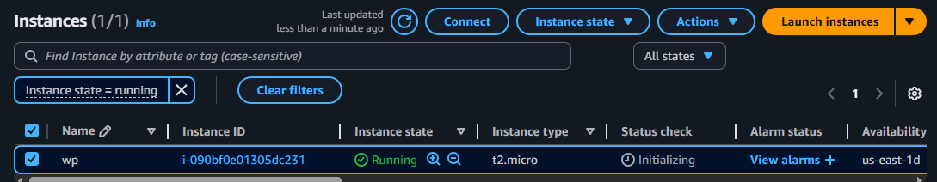
Then SSH into server:
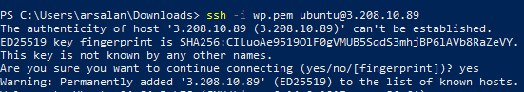

Step 2 — Create a Deployment Script:
Create the file:
Inside of script file:
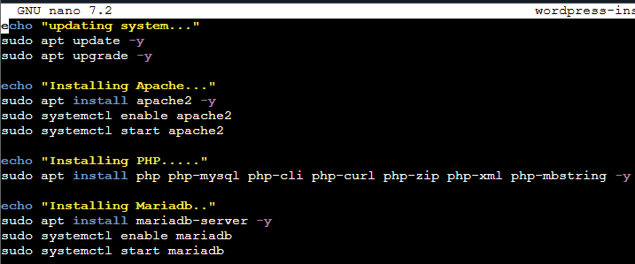
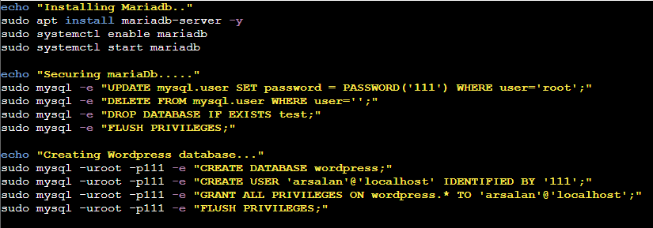
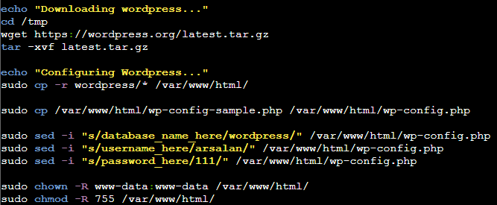
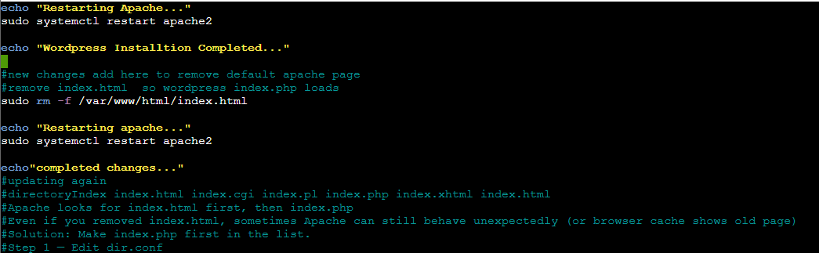
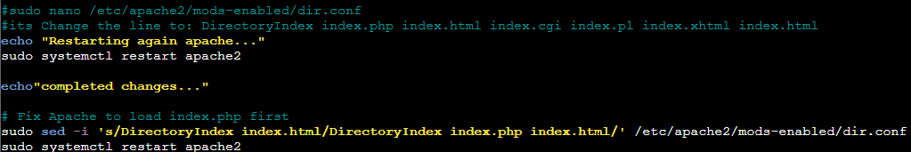
Save the script file (ctrl+x), then press Y and enter.
Step 3 — Make Script Executable:
Step 4 — Run Script:

Installation Complete:
Now open on broswer: http://YOUR-EC2-PUBLIC-IP
